# Video Deciding what to try next

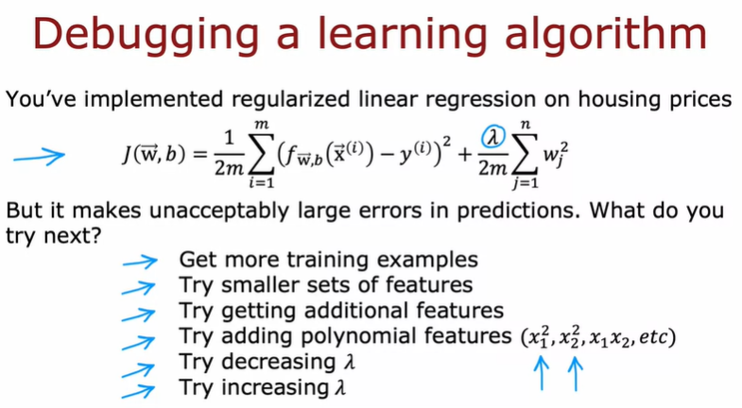

 if you train the model, and find that it makes unacceptably large errors in it's predictions, what do you try next? When you're building a machine learning algorithm, there are usually a lot of different things you could try. For example, you could decide to get more training examples since it seems having more data should help, or maybe you think maybe you have too many features, so you could try a smaller set of features. Or maybe you want to get additional features, such as finally additional properties of the houses to toss into your data, and maybe that'll help you to do better. Or you might take the existing features x_1, x_2, and so on, and try adding polynomial features x_1 squared, x_2 squared, x_1, x_2, and so on. Or you might wonder if the value of Lambda is chosen well, and you might say, maybe it's too big, I want to decrease it. Or you may say, maybe it's too small, I want to try increasing. On any given machine learning application, it will often turn out that some of these things could be fruitful, and some of these things not fruitful. The key to being effective at how you build a machine learning algorithm will be if you can find a way to make good choices about where to invest your time. For example, I have seen teams spend literally many many months collecting more training examples, thinking that more training data is going to help, but it turns out sometimes it helps a lot, and sometimes it doesn't.

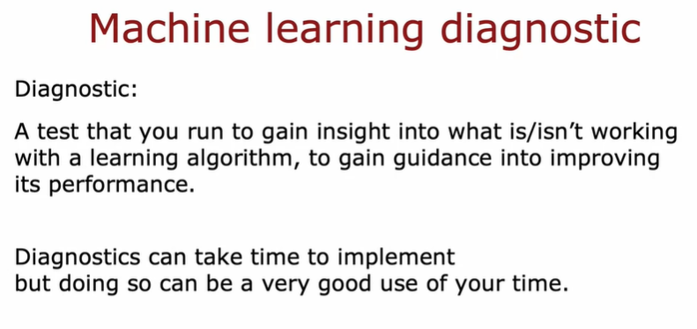

you'll learn about how to carry out a set of diagnostic. By diagnostic, I mean a test that you can run to gain insight into what is or isn't working with learning algorithm to gain guidance into improving its performance. Some of these diagnostics will tell you things like,

is it worth weeks, or even months collecting more training data, because if it is, then you can then go ahead and make the investment to get more data, which will hopefully lead to improved performance, or if it isn't then running that diagnostic could have saved you months of time. One thing you see this week as well, is that diagnostics can take time to implement, but running them can be a very good use of your time. This week we'll spend a lot of time talking about different diagnostics you can use, to give you guidance on how to improve your learning algorithm's performance.

# Video Diagnosis Bias and Variance

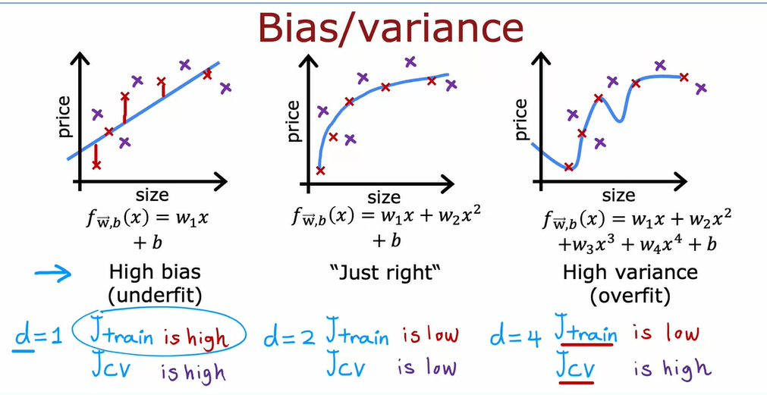

The visualization above explain how to choice good model. The good model have low of Bias (Jtrain - Cost Function in Data Training) and low of variance (Jcv - Cost function in Cross Validation) .

In the case above the good model have d = 2.

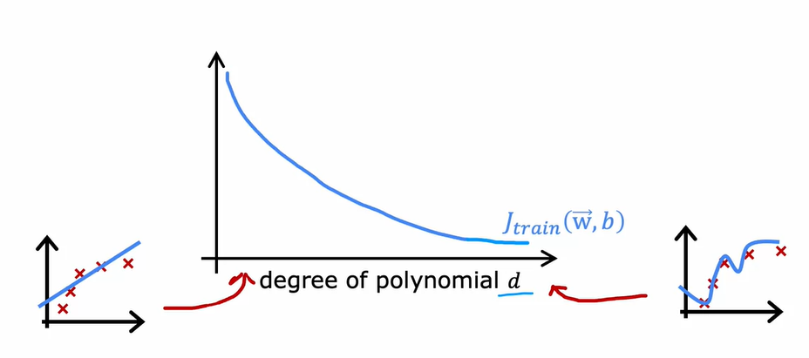

This is diagram for Cost Function base on degree of polynomial. The Cost Function Training (Jtrain) always degres if we are add more degre of polynomial. if degre very smal the model can be underfiting and if degre have many degre the model can be overfitting, those condition overfitting and underfitting is not good for model. So to check what model that good or not, we are must Cost Function Cross Validation.

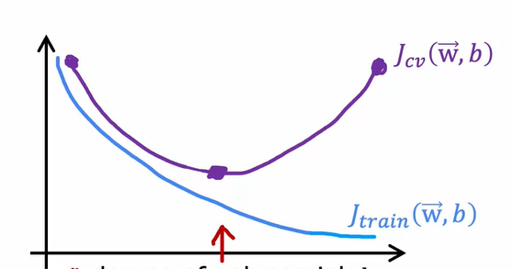

The Cost Function Validation (Jcv) have small value in middle degre of polynomial. If the degre very small Jcv still high , and the degre very big Jcv also high. So we must choice when the Jcsv in minimun values. In this case the Jcv can be minimum value when degree in middle area.

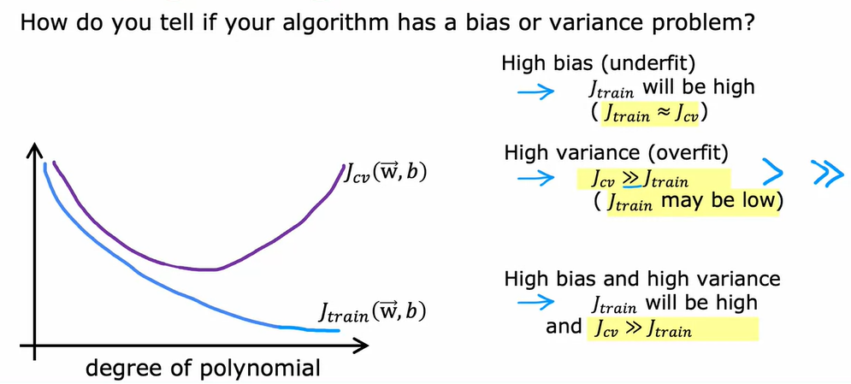

# Video Regulisation and bias/variance

The regulisation is it one of technik to handle overfitting.

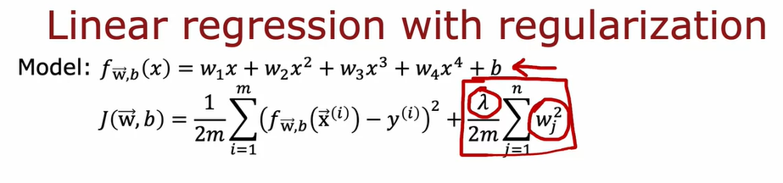

To use regulisation we add some equation in cost function like above.

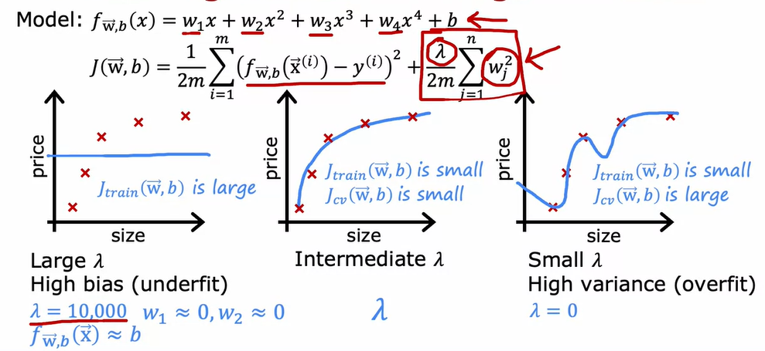

The lamba (λ) have impact for model. If we are define lambda to large the model can be underfit, or if we are define to small the lambda can be overfit. So we must find optiomum value of lambda that not underfit or overfit.

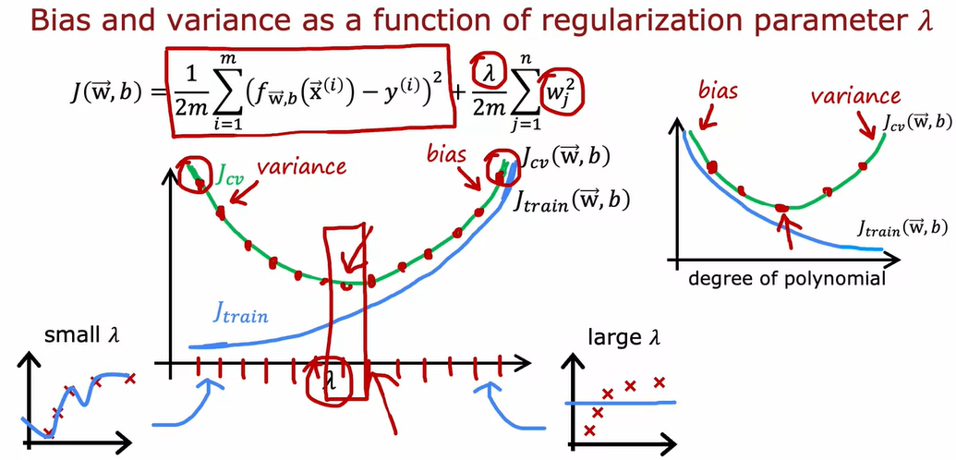

Same with previous vidoe to check and find the best value of lambda we must use Cost Function in Cross Validation.

# Video Establishing a baseline level of performance

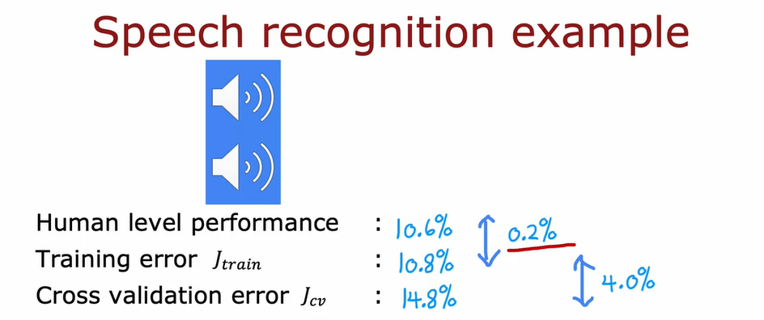

Example we have model Speech Recognition. In this case we have Human Level Performance error 10.6 %, why human have error because sometime the sound or speech have noise and not clear, so human can’t understand , so that reason why human still have error.

And that we have Training Error JTrain 10.8, this is just have interval 0.2 % this is good accuracy if we are kwow acutaly human just have 10.6% error.

But if we are use Jcv the error 14.8% and interval between training erro 4% , the differentiation is very high.

Is it importance to make **baseline level of perfomance,** sowe can manage we are expectation.

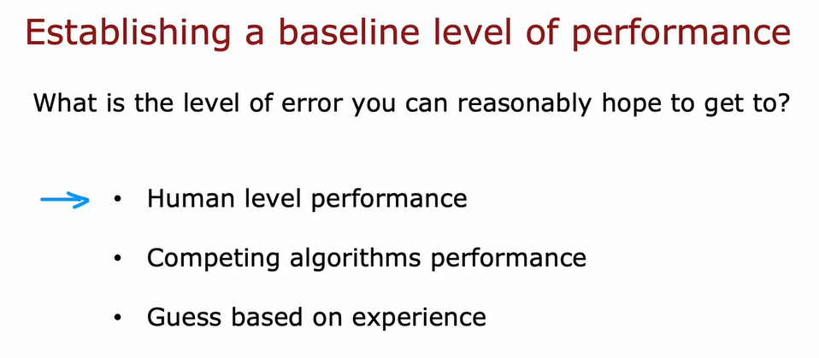

We have three reasonably.

- human level perfomance, because human have good sence in audio, image or other.

- Competing Algorithms performance. Everyone know there is not any model have accuary 100%

- Guess base on experience.

# Learning Curves

Learning Curve is Curve Cost Function by total of training data.

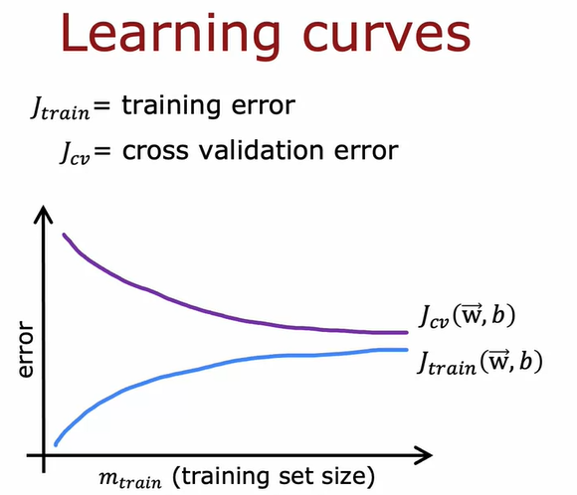

if we are add more data Jcv will be decrease, and Jtrain willl be increase.

But why Jtrain will be increase.

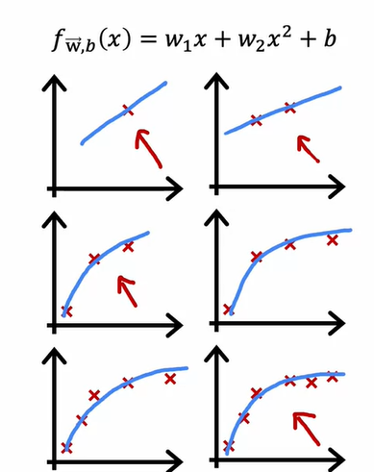

For example if we are have a small training data, the model can be easy to fit with data, but if we are have a lot of data the model will be more difficult to fit with data.

This is learning curve as general. After that we can analysis the impact of add training data to Jcv and Jtrain.

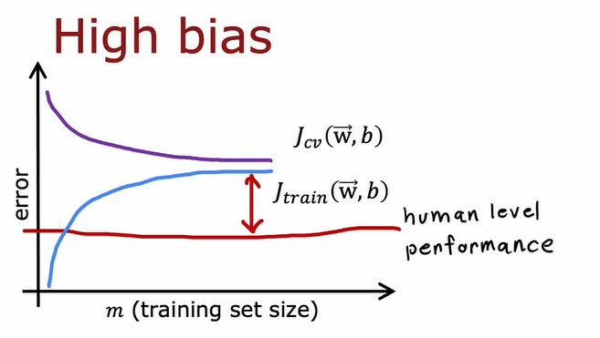

The first if we are have model with high bias, Jcv and Jtrain will be closed, but gap between human level perfromenace/base line is large. and then what do you think if we are add more data.

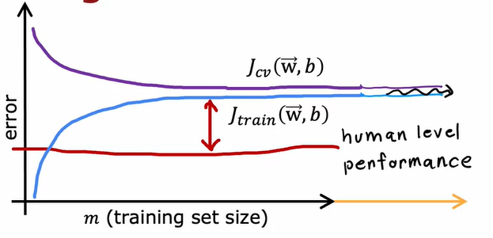

If we are add more data Jcv and Jtrain we don’t have more impact, just a little. That why , we can see in this visualisation.

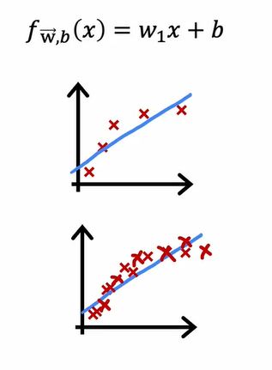

Base on visulisation we are know the add more data will not help full if we are have learning algoritm suffers from high bias.

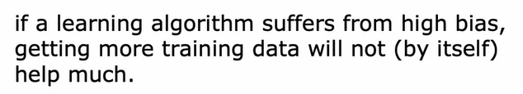

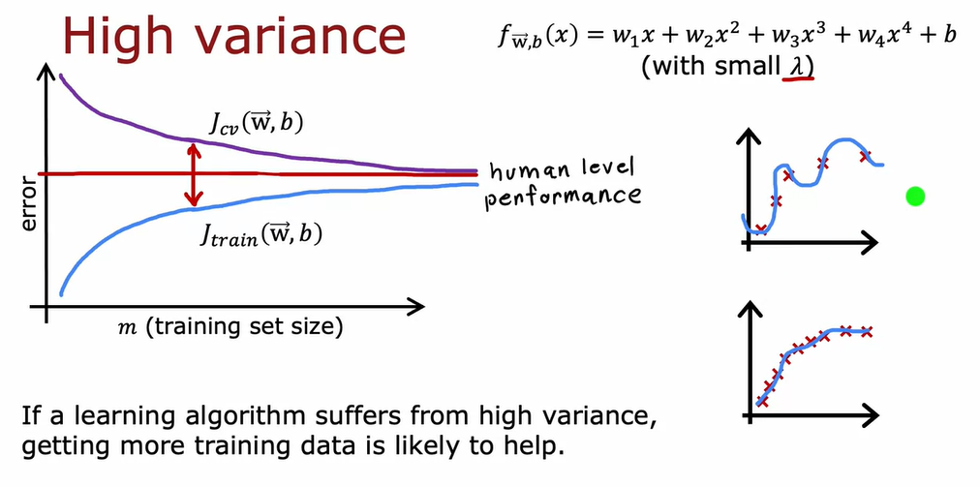

If we add more training data with Learning algorithm suffers from high variance , that can helpful to help make closer to human level performance.

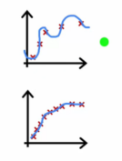

This is visualisation how the more data can be impacful in high variance data.

# Video Deciding what to try next revisited.

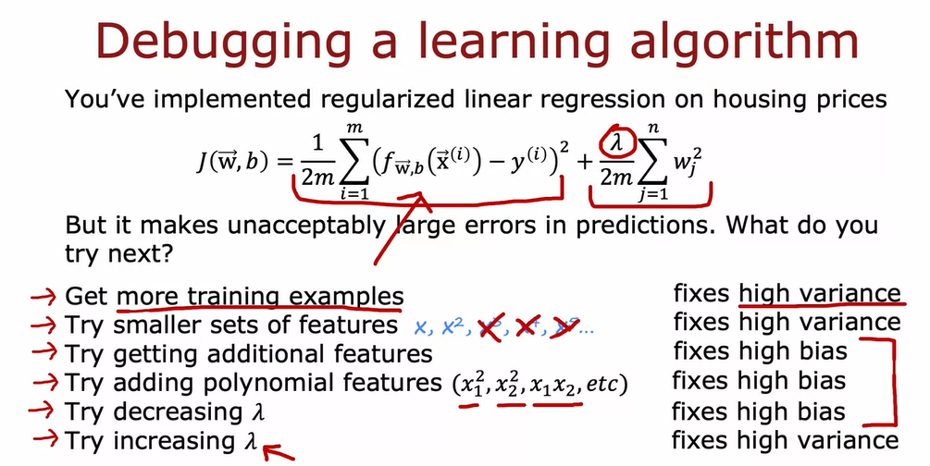

# Video Bias/Variance and Neural Network

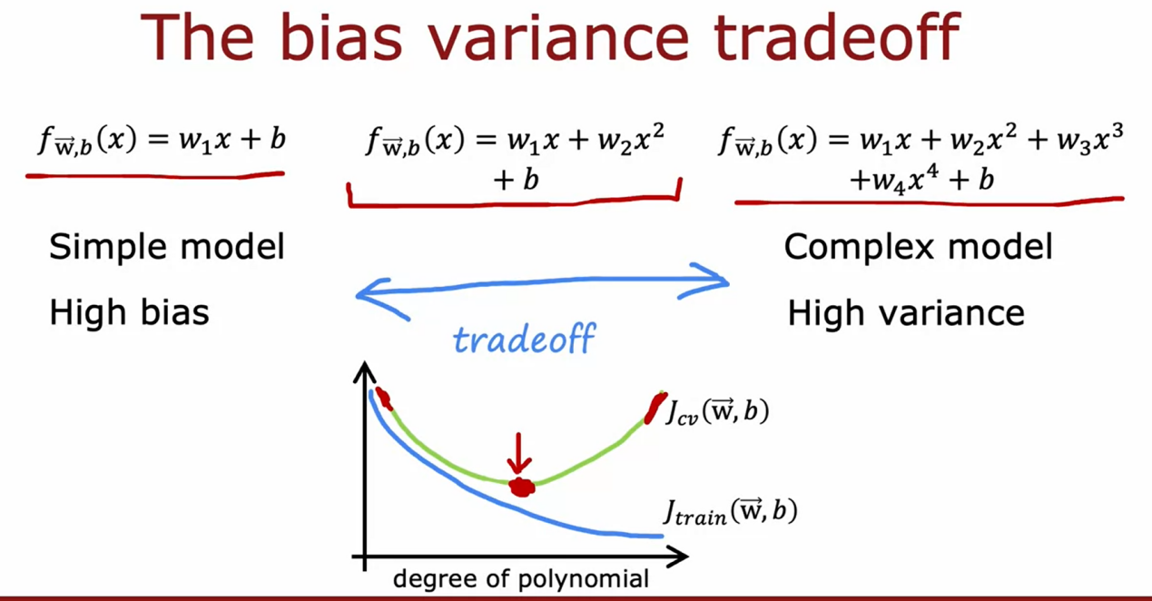

This grafik show how the simple or complex model impact to Jcv and Jtrain.

And then we can show flow to find best neural network

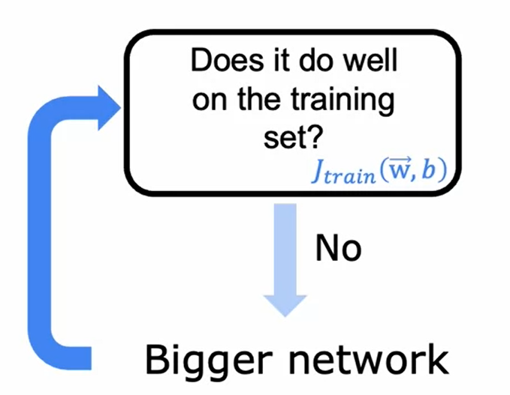

The first doing some simple network model and then if Jtrain not good enough we add mode layer and node until Jtrain have good value.

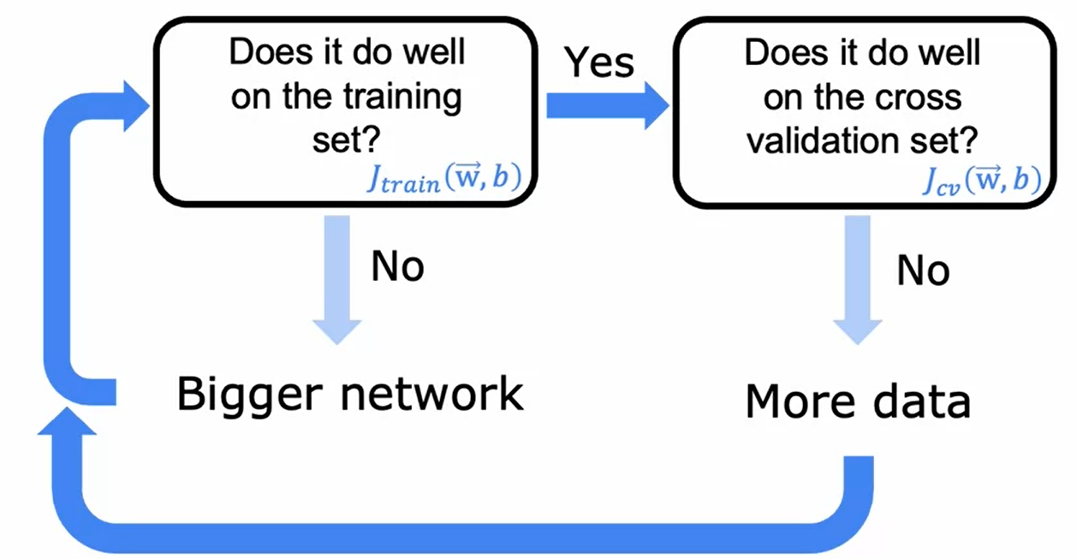and then we check model with cross function if Jcv have a little value that indicated the model high variance so we add more data to model until Jcv have good enough model .

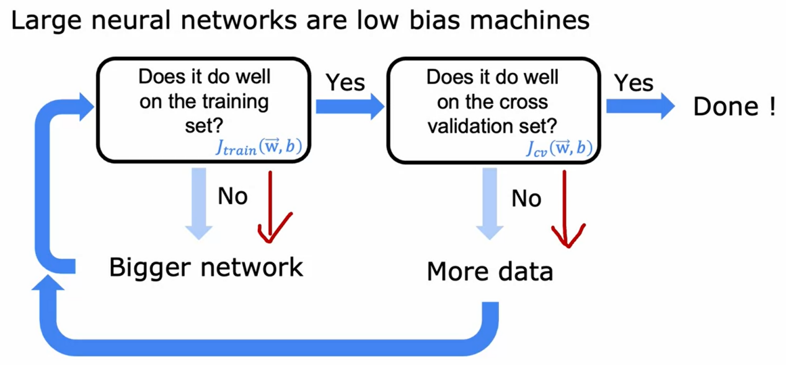

-----------------------------------------------------------------------

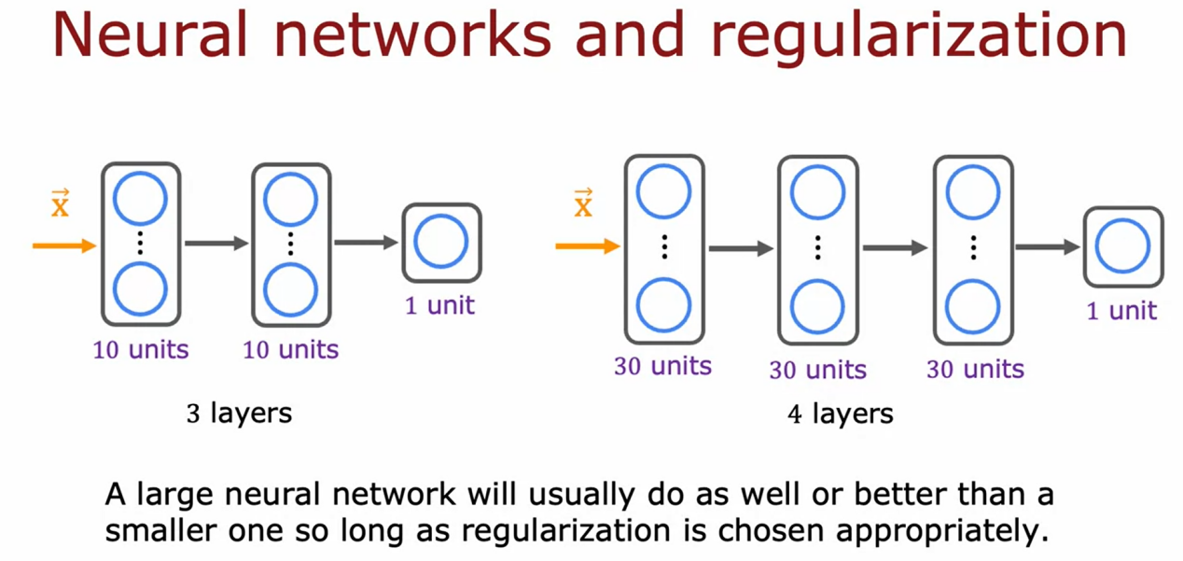

The neural network usually do as well or better than a smaller one so long as regularization is chosen appropriatly.

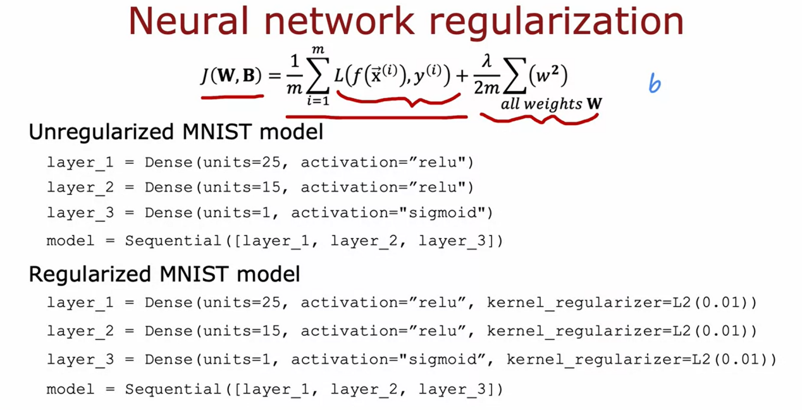

# Video Iterative loop of ML development

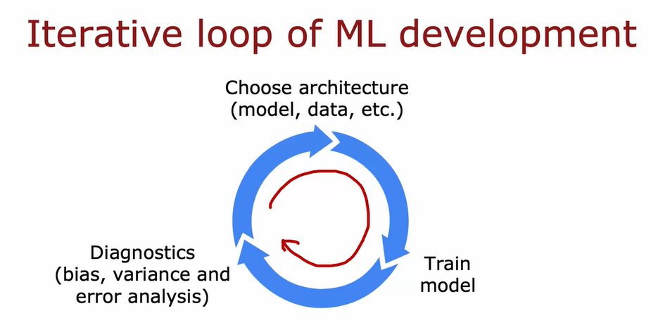

This is iterative loop for ML development. The first step is choose architectur like model, data and other , after that we are training model, and than diagnostics result of training like bias , variance and error analysis.

For example in Building a spam classifier

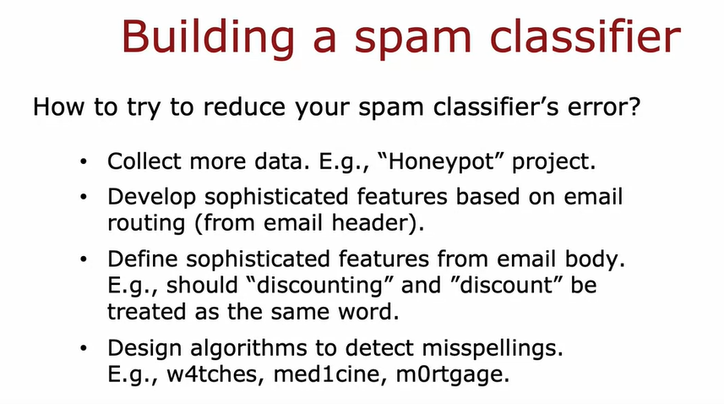

# Error Analysis

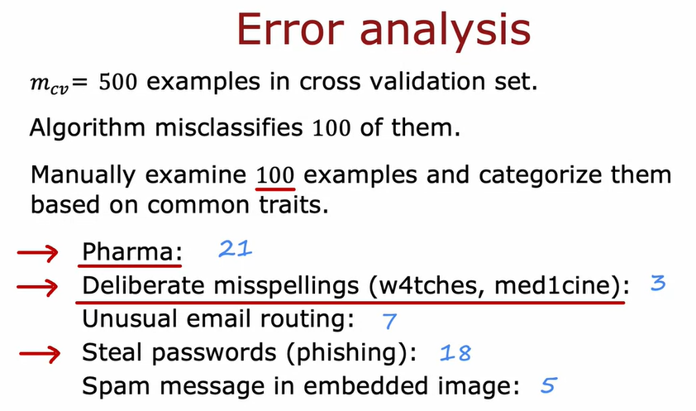

After we analysis the error we can define the good way for handle or increase the accuracy data.

For example if wa are know we have missing in pharma topic 21 data error, we can just collect more data with pharma topic, or create new feature for farma topic data.

# Video Adding Data

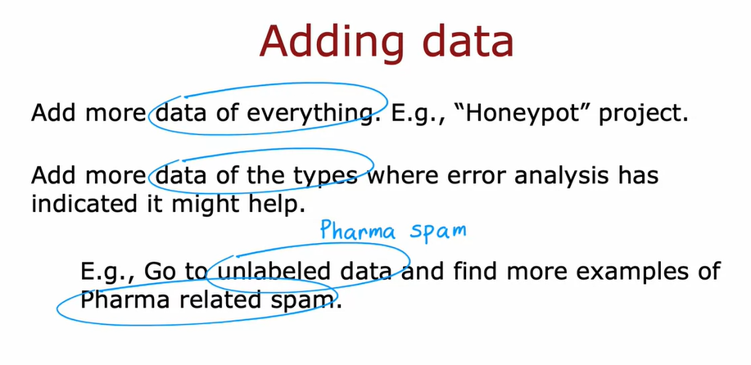

Adding data, actually we can just collect data of everthing to add data, but for more efficient cost and time. The first we can do some analysis error to choice right data that want we add.

Beyond getting brand new training examples (x, y) another techniuque is Data Augmentation

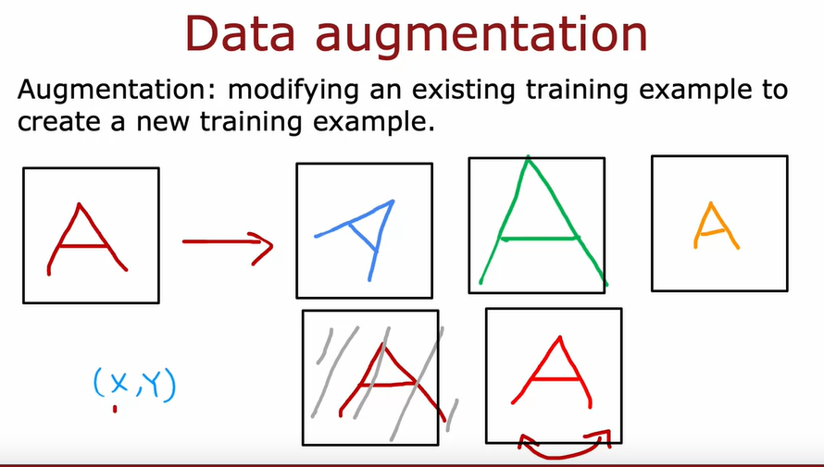

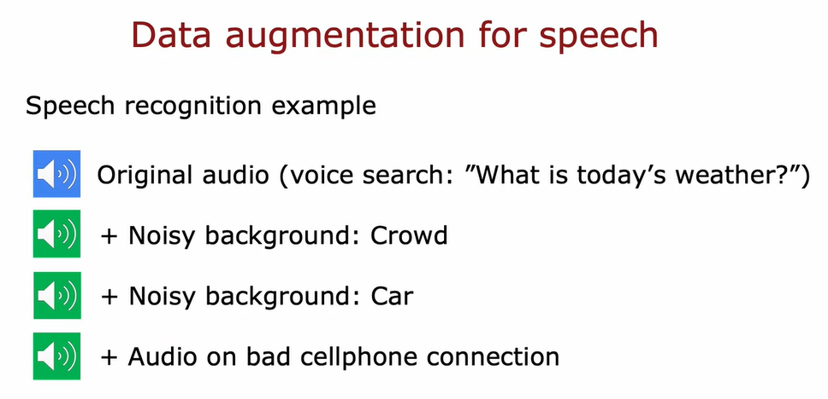

And the other wa to add data is it Data Synthesis.

Synthesis : Using artificial data inputs to create a new training example.

For example in 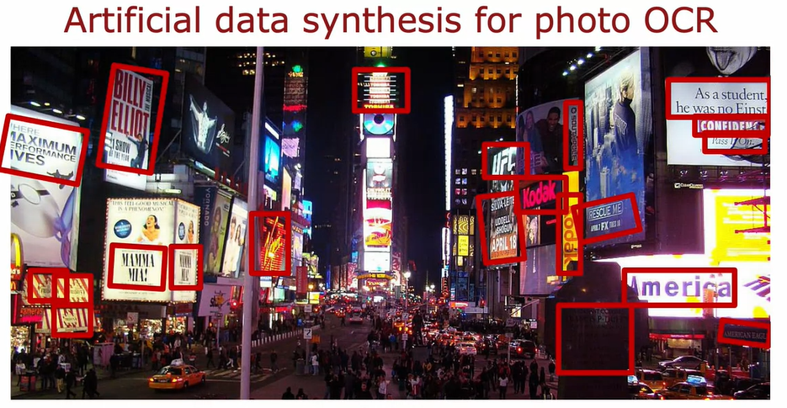

In photo OCR we have data like this

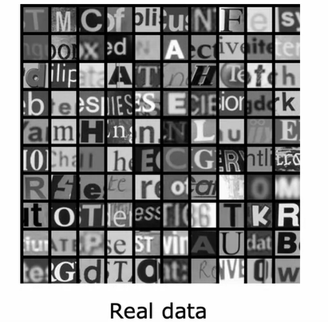

And than we can create again every single alphabate with diffirent style font

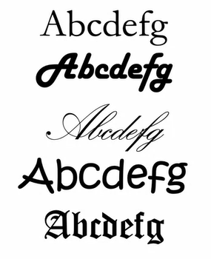

And re create new one.

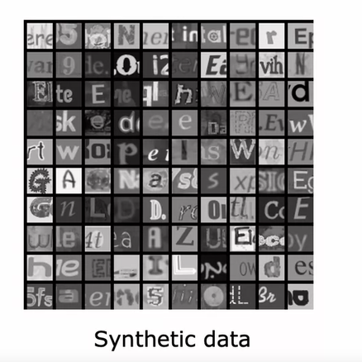

If are look that, it very similar with real data.

# Transfer Learning

This is proces Transfer Learning

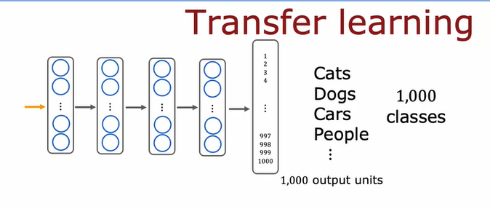

The first we can training 1 milions images for 1.000 output unit for the find weight (w) and bias (b).

So after we are find w and b

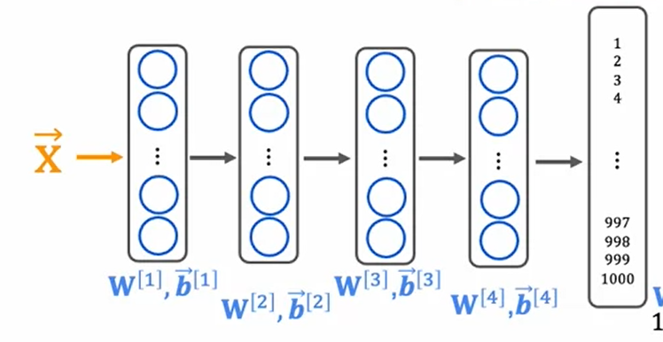

So the transfer learning has ready.

After than in outher case if we are want detect just for 10 output unit, we can user the weight and bias in previous training.

We have 2 option for adapt the transfer learning .

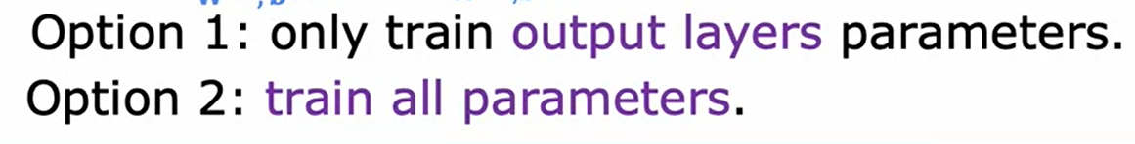

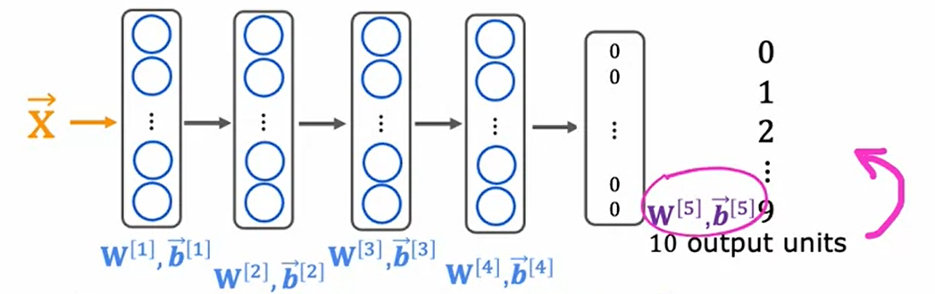

Then the second step is called **fine tuning** where you take the parameters that you had initialized or gotten from supervised pre-training and then run gradient descent further to fine tune the weights to suit the specific application of handwritten digit recognition that you may have

If you have a small dataset, even tens or hundreds or thousands or just tens of thousands of images of the handwritten digits, being able to learn from these million images of a not quite related task can actually help your learning algorithm's performance a lot

One nice thing about transfer learning as well is maybe you don't need to be the

one to carry out supervised pre-training. For a lot of neural networks, there will already be researchers they have already trained a neural network on a large image

and will have posted a trained neural networks on the Internet, freely licensed for anyone to download and use.What that means is rather than carrying out the first step yourself, you can just download the neural network that someone else may have spent weeks training and then replace the output layer with your own output layer

and carry out either Option 1 or Option 2 to fine tune a neural network that someone else has already carried out supervised pre-training on, and just do a little bit of fine tuning to quickly be able to get a neural network that performs well on your task.

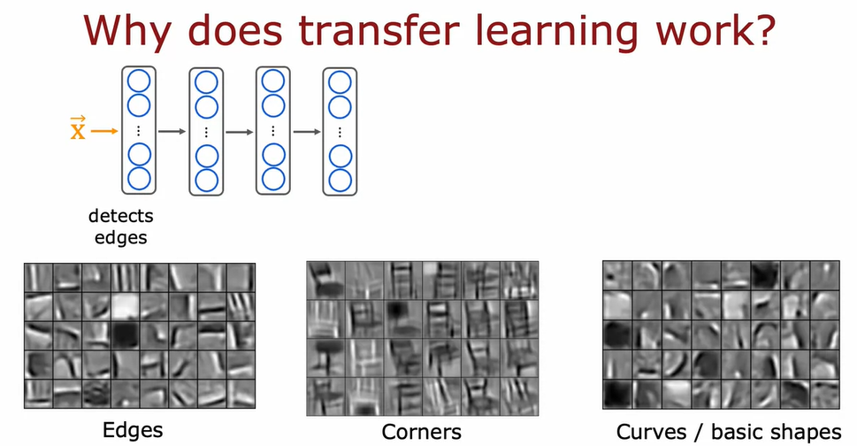

But why does transfer learning even work?

How can you possibly **take parameters** obtained by **recognizing cats, dogs, car**s, and people and use that to help you recognize something as different as **handwritten digits**?

Here's some intuition behind it. If you are training a neural network to detect, say, different objects from images,

then the **first layer** of a neural network may learn to **detect edges** in the image.

We think of these as somewhat low-level features in the image which is to detect edges. Each of these squares is a visualization of what a single neuron has learned to detect as learn to group together pixels to find edges in an image.

The **next layer** of the neural network then learns to **group together edges to detect corners**.

The next layer of the neural network may have learned to detect some are more complex, they store generic shapes like basic curves or smaller shapes.

That's why by learning on detecting lots of different images, you're teaching the neural network to detect edges, corners, and basic shapes.

That's why by training a neural network to detect things as diverse as cats,

dogs, cars and people, you're helping it to learn to detect these pretty generic features of images and finding edges, corners, curves, basic shapes.

This is useful for many other computer vision tasks, such as recognizing handwritten digits.

One restriction of pre-training though, is that the image type x has to be the same for the pre-training and fine-tuning steps. If the final task you want to solve is a computer vision tasks, then the pre-training step also has been a neural network trained on the same type of input, namely an image of the desired dimensions. Conversely, if your goal is to build a speech recognition system to process audio, then a neural network pre-trained on images probably won't do much good on audio.

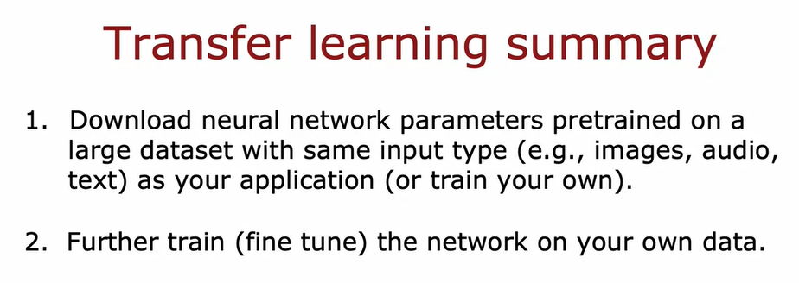

# Video: Full Cycle of a machine learning project

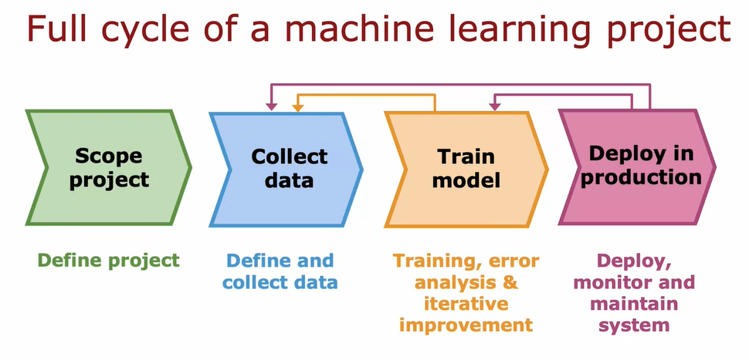

The first step of machine learning project is to scope the project. In other words, decide what is the project and what you want to work on.

For example, I once decided to work on speech recognition for voice search. That is to do web search using speaking to your mobile phone rather than typing into your mobile phone. **This project scoping**.

After deciding what to work on you have to collect data. Decide what data you need to train your machine learning system and go and do the work to get the audio and get the transcripts of the labels for your dataset.**That's data collection.**

After you have your initial data collection you can then start to train the model. Here you would train a speech recognition system and caravel error analysis and iteratively improve your model. Is not at all uncommon.

After you've started training the model for error analysis or for a bias-variance analysis to tell you that you might want to go back to collect more data. Maybe collect more data of everything or just collect more data of a specific type where your error analysis tells you you want to improve the performance of your learning algorithm.

For example, once when working on speech I realized that my model was doing particularly poorly when there was car noise in the background. That sounded like someone was speaking in a car. My speech system perform poorly decided to get more data, actually using data augmentation to get more speech data that sounds like it was a car in order to improve the performance of my learning algorithm.

You go around this loop a few times, train the model, error analysis, go back to collect more data, maybe do this for a while until eventually you say the model is good enough to then deploy in a production environment.

After you've trained a high performing machine learning model, say a speech recognition model, a common way to deploy the model would be to take your machine learning model and implement it in a server

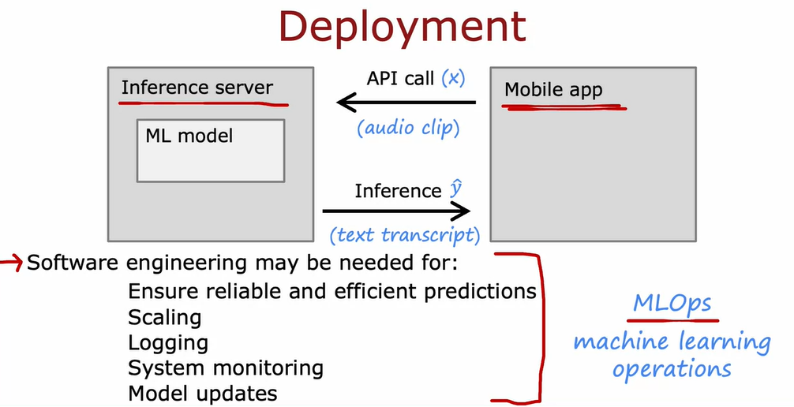

The deployment process can require some amounts of software engineering.

For some applications, if you're just running it on a laptop or on a one or two servers,

maybe not that much software engineering is needed. Depending on the team you're working on, it is possible that you built the machine learning model but there could be a different team responsible for deploying it. But there is a growing field in machine learning called MLOps. This stands for Machine Learning Operations. This refers to the practice of how to systematically build and deploy and maintain machine learning systems. To do all of these things to make sure that your machine learning model is reliable, scales well, has good laws, is monitored, and then you have the opportunity to make updates to the model as appropriate to keep it running well.

# Error metrics for skewed dataset

If we are working on machine laerning application where the ration of positive to negative examples is very skewed, very var from 50-50, then it turns out that the usuan error metrics like **accuracy don’t work** that well.

Lets look the example .

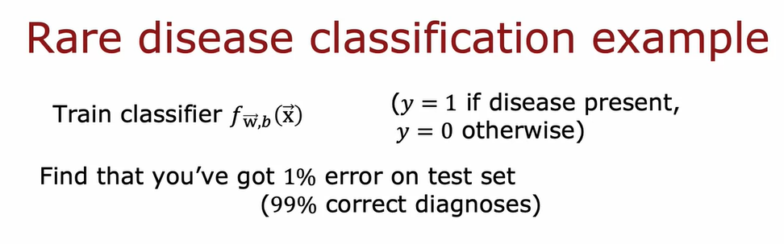

Example we predict some rare disease classification, and we find accuracy 99% correct diagnoses, this is seems like a great outcome.

The actual data have the 0.5 % percent of the patients in your population have the disease, when we just make all of result data 0 the accuracy can be 99.5% . this really dump algoritm.

So in skewness we cant use accuracy for Error Metrics.

So we can use Precision/ recall for error metrics skewness

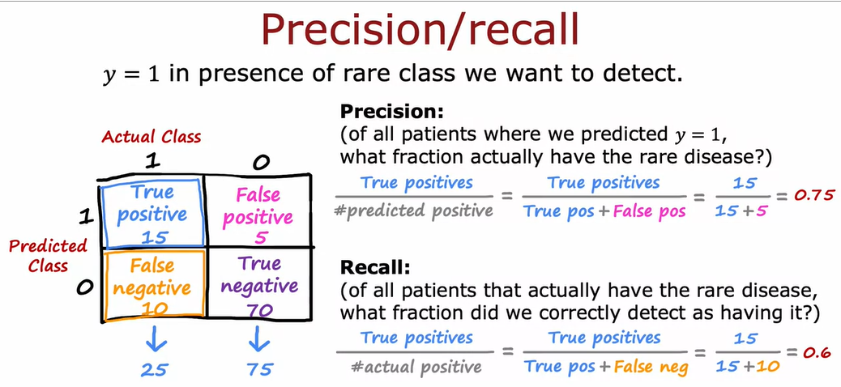

For example we want analytic metrix for y = 1 (in presence of rare calss we want to detect)

So after use analytic y = 1, you can analytic y = 0 .

# Trading off precision and recall

For example

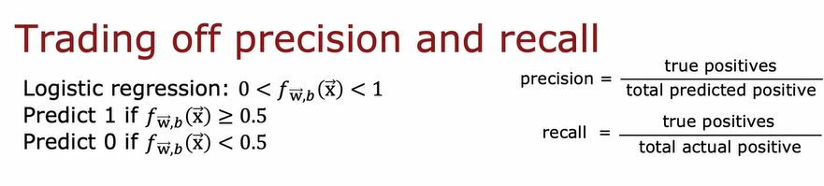

If we are try to increate treshold (very confindent)

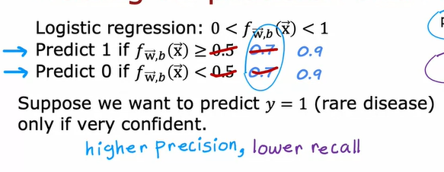

And if we try to decrease threshold

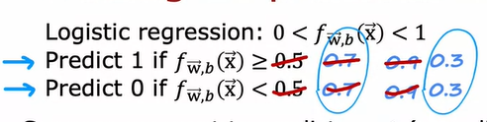

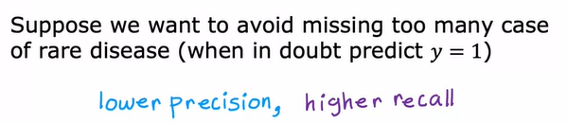

This is diagram for precition and recall

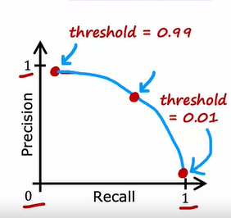

So if we want compare Precision/Recall, how to compare ?

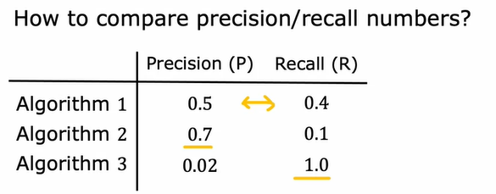

We can confuse because have two metrix error , so for the combine result between recall and precision we can use F1 score

